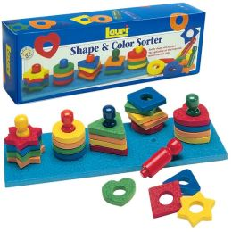
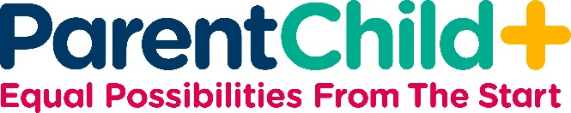

GUIDE SHEET: TOY

COLOR & SHAPE SORTER

Program Year: 1

Supporting Your Child’s Development: This toy will support your child’s cognitive development by having her/him figure out the various ways to sort the pieces, by shape or color. This sort of problem-solving is related to math readiness. This toy also promotes hand-eye coordination and fine motor skills development, a pre-cursor to the ability to write. As your child explores the toy under your guidance, she/he learns how to self-regulate her/his behavior (by being patient, taking turns, and tolerating some frustration), a vital part of school readiness.

Name and encourage your child to name:
- New words: Heart, triangle, square, star, peg, circle
- Colors: Red, green, yellow, blue
- Shapes: Heart, triangle, square, star, circle
- Sizes: Small shapes, skinny peg
- Numbers: Four stars, circles, etc.; four yellow pieces, green pieces, etc.
- Relationships: Put the yellow star on top of the yellow circle; fit the blue peg into the hole; the red peg is next to the green peg
- Textures: The board has a smooth side and a rough side
- Causing things to happen: Carefully put the yellow circle on the yellow peg; put the red peg into the last hole.

Describe your actions. Invite the child to describe his or her actions:
- General: I’m putting the red peg into the hole. Can you put the yellow peg into another hole? Now tell me which shape you are going to put on the yellow peg.
- Sorting and Matching: Let’s try putting all the blue pieces on the blue peg. Now let’s try putting all the circles on the blue peg.
- Fitting: Carefully fit the red peg into the hole.

Remind the child to think about what s/he is doing:
- To Get Child's Attention: Can you put all the pegs in first?
- To Make a Choice: Do you want to find all the red shapes or all the blue shapes?
- To Encourage Self-control: Let’s get all the pieces out of the box before we begin to play. Can you help do that?
- To Remember Other Experiences: What else has a round shape?
- To Do Things in the Right Order: Let’s put all the pegs in the board before putting the shapes on the pegs.

Fun activities:
- Help your child trace around the shapes with a pencil on to a piece of paper. Then use a crayon and help your child color the shapes in.
- Take all the pieces of one color and hide them behind your back. Ask your child which color is missing. Then try taking all the circles or all the squares (etc.) and putting them behind your back. Ask your child which shape is missing. Once your child understands the games, he/she can do the hiding of the pieces and have you figure out which color or shape is missing.

