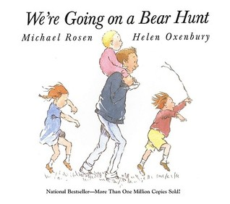
GUIDE SHEET: Book

WE’RE GOING ON A BEAR HUNT

BY: Michael Rosen and Helen Oxenbury

Program Year: 2

Supporting Your Child’s Development: This classicbook features repetitive and rhythmic text, an important reading strategy that will support your child’s early literacy skills. It will spark conversation about the concepts of “over,” “under,” and “through.” The sounds in the book will support your child’s phonemic awareness (ability to hear different sounds within words), the basis of phonics (an approach to learning how to read and write), which are essential school readiness skills. Talk about the illustrations and ask your child what he/she would do in each situation (a component ofproblem-solving) and how each situation makes her/him feel (being able to label and talk about feelings is an essential part of social-emotional development).

Remember the following when reading a book with your child:
- Have a good time with this book and the child!
- Invite the child to look and listen.
- Try to sit the child beside you or between you and your PCHP Home Visitor.
- Show and read the title page to the child.
- Show and describe to the child how to turn the pages and treat the book.
- Read to the child in a clear, easy voice. Don’t go too fast. Allow time for the child to think about the story.
- Stop at most illustrations to talk about them. Ask the child questions about the illustrations to help the child reason things out.
Encourage the child to point out and name:
- Colors: Brown bear, Pink blanket, Green grass, Blue water
- Shapes and Sizes: Giant bear, Tall grass, Little baby
- Numbers: Five family members, Three children, One bear
- Relationships: The family walked through the river. The children walked next to each other. The father carried the baby on his shoulders.
- Textures: Squishy mud, Soft blanket
Invite the child to tell about experiences related to the story and pictures:
- Have you ever gotten wet? Where?
- The bear was scary. What else is scary?
- How many people are in your family?
- Have you ever walked in the snow? What did it feel like?
- Have you ever seen a lot of trees? Where?

Have the child reason things out and make choices:
- What would you do if you saw a bear?
- How would you get across the river?
- Why is it a good idea to wear boots when walking through the mud?
- Why did the family never want to go on a bear hunt again?
- Why is the family hiding under the blanket?

Remember throughout the home visit to:
ENCOURAGE the child to talk. PRAISE the child for doing well.
ASK the child questions. HELP the child when needed.
LISTEN to the child’s answers. RESPOND to the child’s answers.

Fun activities:
- As you read the story, act out the parts by skipping, tip-toeing, pretending to splash, etc. Make the noises of the actions. Pretend that you are going through the woods, through a river, etc.
- Have your child chant the repetitive verses, “We’re going on a bear hunt (etc.)” Then ask your child what is going to happen next. Use the pictures as clues.

