For more information, please fill out
and mail to the address in the next
column or return it to the office or person who gave it to you.

Child’s Name: ______________________________________________________________

Child’s Date of Birth: ________________________________________________________

Parent’s Name: _____________________________________________________________

Address: __________________________________________________________________

Telephone: ________________________________________________________________

Language(s) Spoken at Home: _________________________________________________

PERSONALIZED CONTACT
INFORMATION PAGE

Your Site/ParentChild+

Coordinator Name, Title
Address
Telephone Number
email

Assistant Coordinator Name, Title
Address
Telephone Number
email

(INSERT THE LOGO OF YOUR SCHOOL, NON-PROFIT, ETC.)



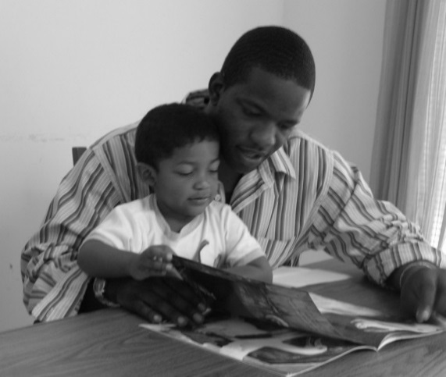

ParentChild+ works with parents and their two and three-year-old children in one-on-one home visits to help parents prepare their children for school success.

“I have learned that reading and talking encourages the young child to want to learn more.” - Program Parent

